**Shell Scripting**

1. Extension of the shell file in .sh
2. You need to make it an executable before you could run it. (chmod +x <file_name>)
3. You can run it just by calling its name - ./script_name.sh
4. Below is my first script, which takes backup of a whole directory, please find the minute observations. 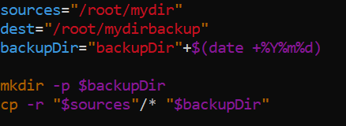
   1. Declaring variables does require $sign. But while using them $sign is required.
   2. Spaces play a major role! DO NOT GIVE SPACES or it will fail
   3. See how date command needs to be inside a $() to be used with a string. And concatenation works with +
5. Output:  
   